Mini Project 2

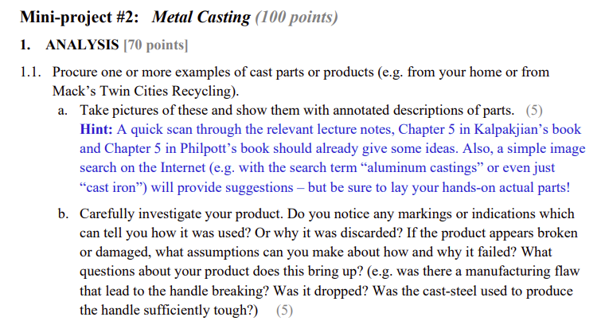

This is a part from an open-fire stove that is used to balance the pots and pans placed on it. The part is made out of cast iron. The body is mainly a large circle, with four indents carved out on the bottom to fit onto the four corners of the stove. There is a huge opening in the middle that maintains the open-fire feature of the stove, and a flattened platform to put the flat-bottomed pans on. The middle opening also allows for placement of a traditional wok, which has a spherical bottom. A curvature between the platform and the inner opening gives it a secured and stable structure. It also traps in the open fire from the stove to prevent the fire from getting too big and out of control(sometimes that happens with open-fire stoves). On the flattened platform there are four squares with wavy structures on it to increase friction between the pan and the part to enable further stability. The general surface of the part has rough finishes.



As you can tell this part is not originally part of the stove. It already has some markings on the flattened platform, because that is the surface that creates an interface with the metal/steel bottoms of pots and pans. There are some scratches and wearings on it. It is quite a heavy piece of metal that is pretty long lasting. There are some stains on the platform as well, from the condiments and grease that might have fallen out of the pan as we cook. The part has been in use for about three months now, and is expected to be in use for at least another couple of months.



The following are the photos for our next casted part. The first picture shows a regular gas stove burner, which includes a pedestal, sensing mechanism, burner body, and burner body cover. The part observing is the burner body which is underneath the black buner body cover. Once a pot is stationed on the pedestal, the sensing mechanism pushes down acting as a safety measure incase. The black burner body cover can easily be removed by just lifting up the part. Now the burner body is shown with two holes in the three middle, threads along the side of the circled part, and a relatively small hole on the side. The centered hole is for the safety sensing mechanism, while the two holes next to the centered hole are the paths the gas comes through. The small hole on the side is where the spark plug is located once assembled with the stove. When the gas stove is on, the area between the burner becomes a chamber where the gas from the two holes in the middle ignites by the spark from the side of the hole. The flames then go through the threads on the side, while the burner body cover redirects the flames to the threads. Therefore, the flames come out of the side of the burner body.

There is a mark on the main burner body with brown coloring. This may indicate that there was an incomplete burn within the burner or some food was burnt in the burner body. The part is not discarded. The burner body is still in use. The burner body was made well, the part is durable with easy removal and maintenance.

1.2. It is known that pouring molten metal at a high rate into a mold has certain disadvantages. Are there any disadvantages to pouring it very slowly? Explain. (5)

* Depending on the cooling rate of the molten metal, pouring metal into the die very slowly could allow the metal to cool and form a surface before the cast is filled. Gas from the metal may not be fully released due to this effect as well. As a result, this would lead to porosity and internal cavities and cause the metal to be more vulnerable and susceptible to cracking and breaking.
* Information from Prof. Leibenburg’s notes

1.3. A spoked hand wheel must be cast in gray iron. To prevent hot tearing of the spokes, would you insulate the spokes or chill them? Explain. (5)

Gray Iron has a volumetric solidification expansion of 2.5%. Therefore, insulating the spokes would possibly contradict the tendency to contract during cooling. Chilling the spokes would increase the strength of the spokes while reducing the possibility of hot tearing.

1.4. Why are risers not as useful in die casting as they are in sand casting? (5)

* Risers are reservoirs built into metal casting molds in order to prevent the formation of cavities due to shrinkage during the cooling process. In sand casting, the cooling rate is lower and the risers can be sized and located specifically to provide molten metal to the die cavity to compensate for metal shrinkage. This also allows manipulation of the cooling rate through the size and placement of risers. However, in die casting, a high cooling rate is essential in order for the tooling and equipment costs to be economically viable. Using risers in die casting would increase the cooling time and thus would not be economically efficient. Additionally, metals that are used in die casting generally develop internal shrinkage porosity, but do not separate from the walls of the mold, rendering risers unnecessary. Furthermore, risers are not required as the constant high pressure injection of molten metal in die casting ensures a steady and continuous feed of metal into the mold.

1.5. Two halves of a mold (cope and drag) are weighted down to keep them from separating under the pressure exerted by the molten metal (buoyancy). Consider a solid, spherical steel casting, 225 mm in diameter, that is being produced by sand casting. Each flask (see figure) is 0.5 m by 0.5 m and 350 mm deep. The parting line is at the middle of the part. Estimate the clamping force required if the molten metal has a density of 8.96 g/cm3 and the sand has a density of 1.2 g/cm3 . (10)

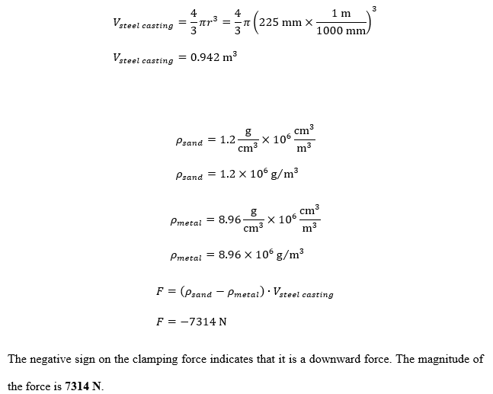

$V_{steel casting}=\frac{4}{3}πr^{3}=\frac{4}{3}π({225mm×10^{-3})}^{3}=0.942 m^{3}$

$ρ_{sand}=1.2\frac{g}{cm^{3}}×100^{3}=1.2×10^{6}\frac{g}{m^{3}}$

$ρ_{metal}=8.96\frac{g}{cm^{3}}×100^{3}=8.96×10^{6}\frac{g}{m^{3}}$

$F=(ρ_{sand}-ρ_{metal})×V_{steel casting}=-7314 N$

The negative sign on the clamping force indicates that it is a downward force.

The magnitude of the force is **7314 N**.

1.6. A 75-mm thick square plate and a right circular cylinder with a radius of 100 mm and height of 50 mm each have the same volume. If each is to be cast using a cylindrical riser, will each part require the same size riser to ensure proper feeding? Explain using Chvorinov’s rule.

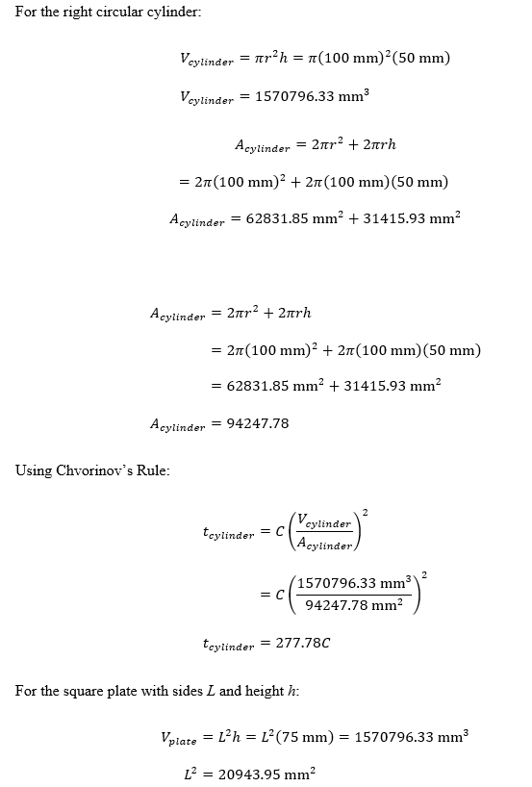

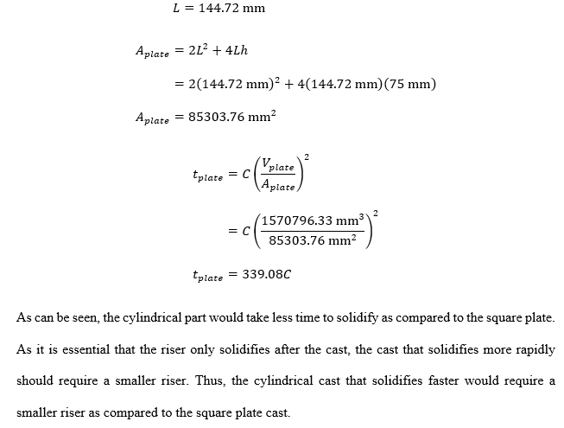

1.7. A sphere with a diameter of 75 mm solidifies in three minutes in a sand-casting operation. The material is A-319, an aluminum casting alloy. Using the same equipment and metal, estimate the time required to produce the spool shown alongside. (15)

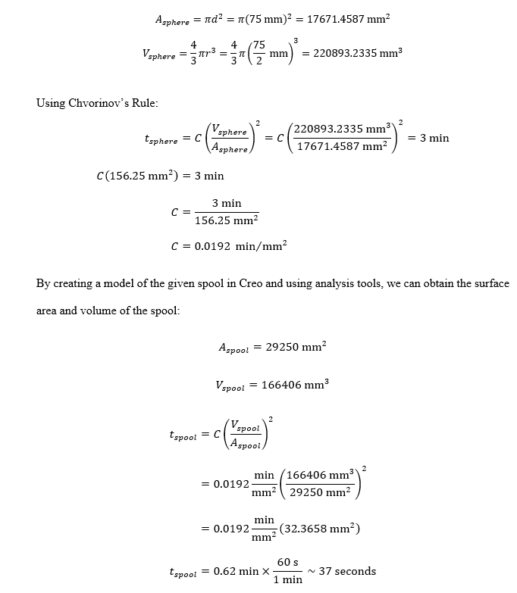

1.8. A jeweler wishes to produce twenty gold rings in one investment-casting operation. The wax parts are attached to a wax central sprue with a 20 mm diameter. The rings are in four rows, each 15mm from the other on the sprue. The rings require a 3 mm diameter, 12mm long runner to the sprue. Estimate the weight of gold needed to completely fill the rings, runners, and sprues. Assume a typical ring has a 25 mm outer diameter, 19 mm inner diameter and 5 mm width. The specific gravity of gold is 19.3. (10)

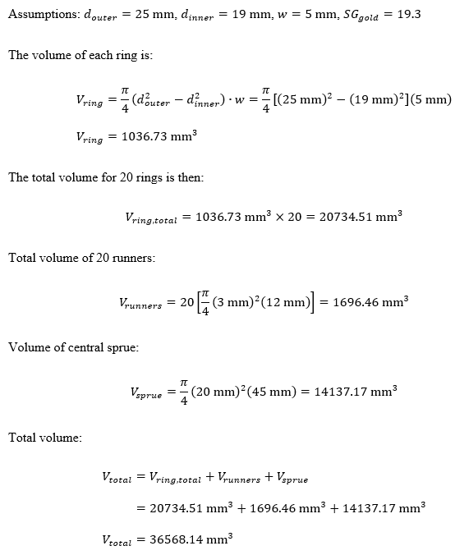

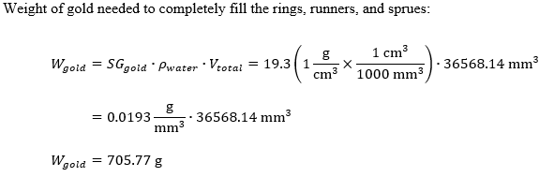

$d_{sprue}=20 mm$

$r_{rows of rings}=4 rows$

$s_{sprue separation}=15 mm$

$d_{runner}=3 mm$

$r_{runner}=12 mm$

$d_{outer ring}=25 mm$

$d_{inner ring}=19 mm$

$w_{ring}=5 mm$

$n_{number of rings}=20 rings$

$h_{sprue}=r_{rows of rings}×s_{sprue separation} = 60 mm$

$V_{sprue}=\frac{π}{4}×d_{sprue}^{2}×h_{sprue}=18849 mm^{3}$

$V_{ring}=n×(d_{outer ring}^{2}-d_{inner ring}^{2})×w=26400 mm^{3}$

$m =ρgV_{total}=0.0086 kg$

The weight of the object is **0.0086 kg**.

**2. DESIGN CHALLENGE** [30 points]

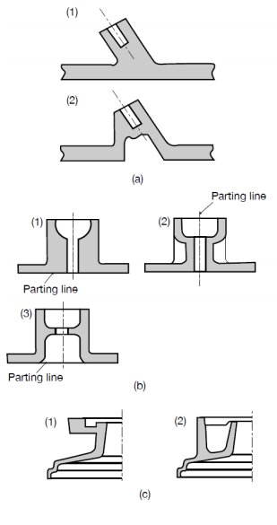

2.1. Three sets of designs (a, b, and c) for die casting are shown. Note the changes made to original die design (1) and comment on the reasons. (10)

1. Sharp corner angle on the left of the parting line was removed to a right angle to manage the stress in that region. Excessive stress centered in one region would result in cracking and tearing of the metal. Reduction of inclined areas will provide a better final product. Lastly, the removal of the excessive material will reduce the production cost of the mold.
2. Both (1) and (3) will have undercut where it’s impossible to remove the part from the mold unless the mold is broken. From (1) to (2) the designer removed excessive material of the mold to reduce the cost of the mold and to have a consistent cross section area of the mold. Flanges have been oriented so that the part can be easily cast.
3. Both (1) and (2) are impossible to remove from the mold. The thickness of the mold has changed to cast and make the mold easily.

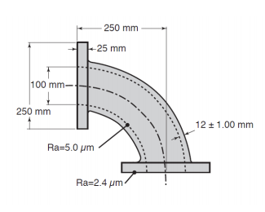

2.2. The following part is to be cast of 10%-Sn bronze at the rate of 100 parts per month. To find an appropriate casting process, consider all the processes discussed in Chapter 5 of the Kalpakjian book, then reject those that are (a) technically inadmissible; (b) technically feasible but too expensive for the purpose; and (c) identify the most economical one. Write a rationale using common-sense assumptions about cost. (10)

|  |  |  |
| --- | --- | --- |
| Process | Note | Cost rationale |
| Sand casting | Most economical process | Sand casting is viable for all types of metals and is suitable for all part sizes and geometries. Tooling cost to create sand mold is low while the sand can be reclaimed and reused to some extent after each casting process, which reduces material costs. Sand casting is also economically suitable for lower production rates. |
| Shell-mold casting | Technically inadmissible | - |
| Plaster mold casting | Technically inadmissible | - |
| Ceramic mold casting | Technically feasible but too expensive | - |
| Vacuum casting | Technically feasible but too expensive | - |
| Evaporative-pattern casting (lost foam) | Economically viable at higher production rates | Requires tooling to produce premade mold. Foam mold is destroyed after casting of each individual part. Patterns also have low strength and are too costly for the aforementioned rate of production. |
| Investment casting (lost wax) | Economically viable at higher production rates | Requires tooling to produce premade mold for wax injection. Wax mold is also destroyed after each individual casting process. Production rate is too low to be economically viable. |
| Pressure casting | Technically feasible but too expensive | - |
| Die casting | Technically feasible but too expensive | - |
| Centrifugal casting | Technically feasible but too expensive | - |
| Squeeze casting | Technically feasible but too expensive | - |

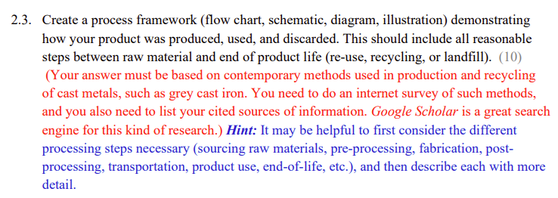

<https://www.sciencedirect.com/topics/engineering/low-pressure-casting>

<https://www.engineeringenotes.com/metallurgy/cast-iron/cast-iron-manufacture-composition-types-properties-and-uses-engineering/46725>